
Jason Petry
Principal
813-794-1501
Kimberly Hedgspeth
Assistant Principal
813-794-1503

Sanders Memorial Elementary School
5126 School Rd. Land O’ Lakes, Florida 34638
(813)794-1500

SMES Policy 1.1- FAST PASS- Security at Special Events during School Day

SKIP THE WAIT AND GET YOUR FAST PASS TO THE EVENT! Stop by the front office at the beginning of the year to have your ID swiped to be “Raptored” into our system. You must be “Raptored” into the system prior to RSVPing for any event. Once your “Raptored” in and you fill out the RSVP for events you can skip the wait line at any Special Event (Field Trips, performances, Showcases, etc.)! Once you RSVP you will get a “Raptored” Guest sticker upon arrival at the front desk or designated table. If you are not “Raptored” in, it may take some time to get everyone into the system and you could miss some of the event. Thank you for keeping our campus safe and secured.

** You may come in anytime to get “Raptored” in throughout the year( lunch time, volunteering,etc.). The earliest you can be “Raptored” in is during “Meet Your Teacher Day. You can even come in after arrival or before dismissal.**

** You must be “Raptored” in every year!**

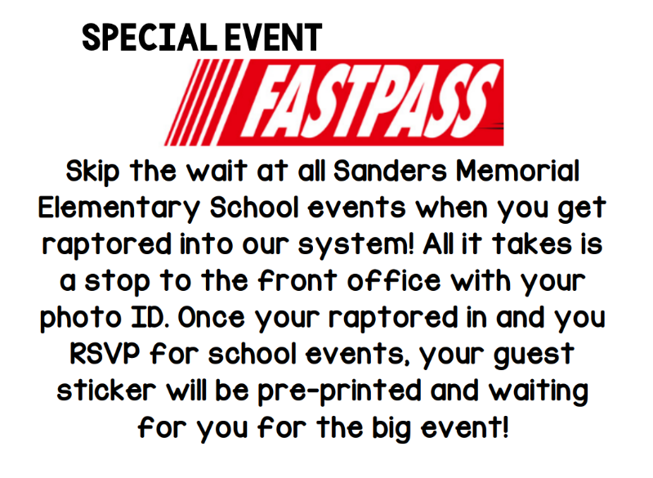
*Updated on 6/25/2025

