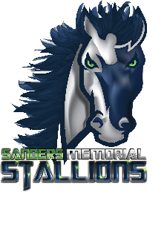
Kimberly Hedgspeth
Assistant Principal
813-794-1503
Jason Petry
Principal
813-794-1501

Sanders Memorial Elementary School
5126 School Rd. Land O’ Lakes, Florida 34638
(813)794-1500

SMES Policy 1.9- Alcoholic Beverages as a Gift

We know that sometimes parents want to give teachers and/or staff gifts that involve alcoholic beverages such as beer, wine and/or liquor. Alcoholic beverages open or closed are prohibited on all campuses throughout Pasco County School District. Please be advised that alcoholic beverages should not be given or taken as a gift from a parent since they are prohibited on campus. If you would like to give a teacher a gift and want to know what they are interested in, you may view this information in the front office.

*Updated on 6/27/2022
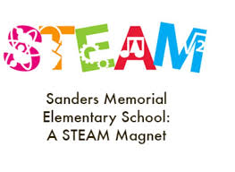
District School Board of Pasco District
Wide Accreditation-Southern Association of Colleges and Schools
Council on Accreditation and School Improvement (SACS CASI)
Kurt Browning, Superintendent

