
Sanders Memorial Elementary Families,
We are thrilled to offer your child the opportunity to attend Sanders Memorial Elementary, a S.T.E.A.M. Magnet, and be a part of authentic, real world learning experiences while strengthening skills around communication, critical thinking, compassion, collaboration, and creativity. Understanding literacy while connecting Science, Technology, Engineering, Arts and Math (S.T.E.A.M.) will provide a variety of learning opportunities to achieve proficiency with Florida Standards at each student’s grade level.
Our focus will be on providing each child with new challenges that will result in a rewarding school experience through the lens of our five design principles:
1. Students first: Decisions will be made with the students in mind.
2. Learners have voice and choice: Empowering learners to take part in designing their experiences.
3. Positive relationships lead to positive outcomes: Relationships within our school community are pivotal to our students’ success.
4. Failing Forward: Building perseverance and grit are key to learning.
5. Changing the World Through Design- Students learn by engineering solutions to real-world problems.
We are looking forward to a productive partnership with you to ensure our children can achieve their highest potential and we recognize that in order to be successful in school, our children need support from both home and school. We know a strong partnership with you will make a great difference in your child’s education. As partners, we share the responsibility for our children’s success and want you to know that we will do our very best to carry out those responsibilities.

Please feel free to contact me by email at anytime if you have any questions. To stay updated with SMES progress, please sign up on Twitter @SandersSMES, follow us on our Facebook at Sanders Memorial Elementary, follow us on Instagram sanderssmes and MOST importantly visit our website at https://smes.pasco.k12.fl.us We thank you for your support and look forward to meeting you in the future.
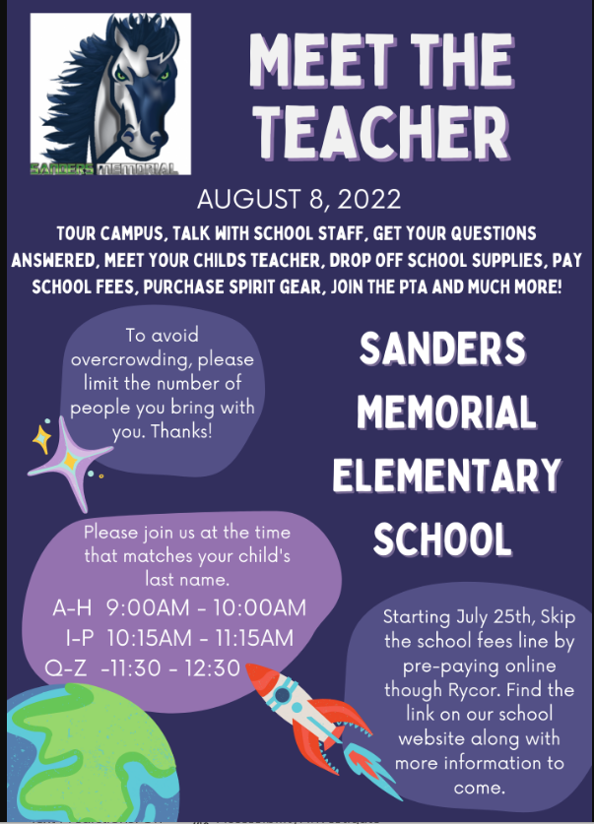
Important Dates:
- First Day of School- Wednesday, August 10, 2022- ALL parents may escort their children to the classroom the first day of school. Please encourage parents to leave by 9:20a.m. to join us in the cafeteria for the BOO-HOO/WAHOO Breakfast sponsored by our SMES PTA and/or exit the campus. This will be only for the first day of school. In the afternoon, parents will not be permitted to pick up their children from the classroom. If a parent comes to a classroom, please refer them to the office.
- Open House/Orientation Night- August 25- Orientation Night- Kindergarten will be held from-4pm-600pm 1st-2nd- 615pm-645pm 3-5- 700-730. More information to come.
Policy/Reminders Updates:
- To pick up your son/daughter at car rider or parker pick up, you must have your car rider sign. No Exceptions!
- Welcome to our new lunch with your child procedures called the SMES Café! More information at “Meet Your Teacher Day”
- Volunteers will be allowed on campus. Schedules will be made by your child’s teacher for volunteering in your child’s classroom. Please make sure you are a registered volunteer.
- If anything changes, please make sure you are registered on Classroom Dojo, follow us on Twitter, FB and always check our website for communication.

Again, welcome to our school,
Jason Petry, Principal, jpetry@pasco.k12.fl.us
Kim Hedgspeth, Assistant Principal, kfoster@pasco.k12.fl.us
Sanders Memorial Elementary- 813-794-1500

